JWT (JSON Web Token)

🔐 What Is JWT (JSON Web Token)?
# Source: Chatgpt (GPT-5-Mini) at [1/20/2026]
JWT stands for JSON Web Token.
It is a secure, compact, URL-safe token used to verify the identity of users and safely transmit data between two systems — especially in authentication and authorization.

✅ Simple Definition:
# Source: Chatgpt (GPT-5-Mini) at [1/20/2026]
A JWT is a digitally signed string that encodes user data (like ID or role) so it can be securely shared between a client and a server.

🧠 Real-Life Analogy:
# Source: Chatgpt (GPT-5-Mini) at [1/20/2026]
Imagine a passport:
- It contains your name and nationality (user data)
- It's signed by a government (token signature)
- Anyone who trusts the signature can verify your identity — without asking the government again

🔧 JWT Structure
# Source: Chatgpt (GPT-5-Mini) at [1/20/2026]
A JWT looks like this:
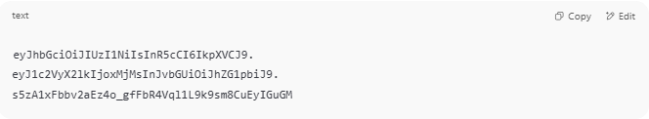
eyJhbGciOiJIUzI1NiIsInR5cCI6IkpXVCJ9.
eyJ1c2VyX2lkIjoxMjMsInJvbGUiOiJhZG1pbiJ9.
s5zA1xFbbv2aEz4o_gfFbR4Vql1L9k9sm8CuEyIGuGM

It has 3 parts, separated by dots:
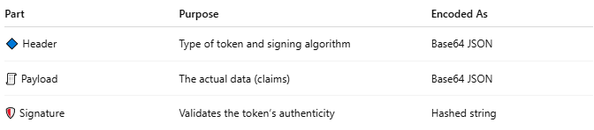

Part | Purpose | Encoded As
🔷 Header | Type of token and signing algorithm | Base64 JSON
🧾 Payload | The actual data (claims) | Base64 JSON
🛡 Signature | Validates the token’s authenticity | Hashed string

🧾 Example Payload (decoded):
# Source: Chatgpt (GPT-5-Mini) at [1/20/2026]
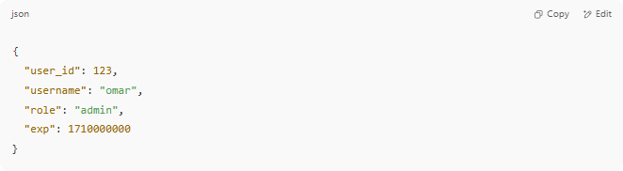

{
"user_id": 123,
"username": "omar",
"role": "admin",
"exp": 1710000000
}

🔁 How JWT Works (Authentication Flow)
# Source: Chatgpt (GPT-5-Mini) at [1/20/2026]
- 👤 User logs in (username/password)
- ✅ Server verifies and creates a JWT
- 🔑 The token is sent back to the browser/app
- 🌐 On future requests, the token is sent in a header:
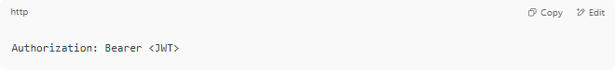
Authorization: Bearer <JWT>

- 🔍 Server checks the token and grants access (no DB lookup needed)

📚 Why Use JWT?
# Source: Chatgpt (GPT-5-Mini) at [1/20/2026]


Feature | Benefit
✅ Stateless | No session storage needed on the server
✅ Compact | Small enough to send via headers or cookies
✅ Secure | Can be signed and even encrypted
✅ Cross-platform | Works on mobile, web, APIs, IoT, etc.

⚠️ JWT Security Tips
# Source: Chatgpt (GPT-5-Mini) at [1/20/2026]
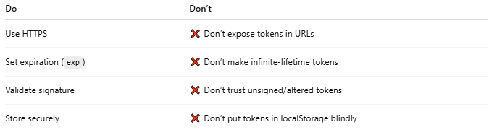

Do | Don’t
Use HTTPS | ❌ Don’t expose tokens in URLs
Set expiration (exp) | ❌ Don’t make infinite-lifetime tokens
Validate signature | ❌ Don’t trust unsigned/altered tokens
Store securely | ❌ Don’t put tokens in localStorage blindly

🔧 JWT Use Cases
# Source: Chatgpt (GPT-5-Mini) at [1/20/2026]
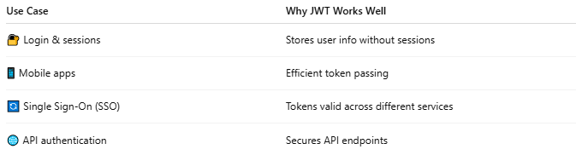

Use Case | Why JWT Works Well
🔐 Login & sessions | Stores user info without sessions
📱 Mobile apps | Efficient token passing
🔄 Single Sign-On (SSO) | Tokens valid across different services
🌐 API authentication | Secures API endpoints

